Determinants of Agricultural Productivity in Ntungamo District

Author: Christine Ainembabazi
Tools: SPSS Statistics v28, Excel
Methodology: Primary Field Survey (N=246), Multiple Linear Regression

Contents
1. Executive Summary 2
2. Methodology & Data Integrity 3
3. Statistical Analysis & Interpretations 3
3.1 Frequency Distribution: 3
3.2 Descriptive statistics 6
3.3 Regression Model Summary: Explaining Productivity 7
3.4 Identifying Strategic Barriers to Growth 7
3.5 The Success Formula: Predictive Drivers of Wealth 8
3.6 The Coefficients Table: The Resource Paradox 10
3.7 Efficiency Outlier Analysis 11
4.Strategic Recommendations 12
5. Conclusion 12

1. Executive Summary
This primary research study identifies the structural and socio-economic drivers of farm income for 246 households in Ntungamo. Utilizing Multiple Linear Regression, the analysis confirms that land size and fertilizer application are the most significant predictors of success, accounting for 79.1% of the variance in productivity. The findings suggest that rural development should pivot from academic instruction toward "input-centric" support and localized vocational extension.

2. Methodology & Data Integrity
Data Source: Primary data collected via face-to-face household surveys.
Data Cleaning: Raw data was cleaned in SPSS. Missing values for "Age" and "Yield" were handled through mean imputation, and outliers were identified via Z-score analysis to ensure the reliability of the regression model.
Analysis: Applied Bivariate Correlation to identify relationships between variables and Multiple Linear Regression to isolate the impact of individual drivers.

3. Statistical Analysis & Interpretations

3.1 Frequency Distribution:

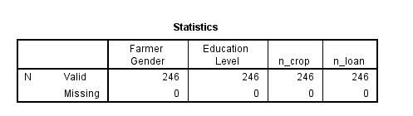
The study analyzed a cohort of 246 smallholder households to identify the human factors driving agricultural productivity in Ntungamo.
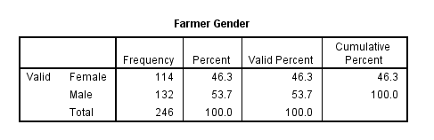
Gender Balance: The sample consists of 132 males (53.7%) and 114 females (46.3%). This balanced distribution ensures that the findings are representative of the entire household structure in the district.
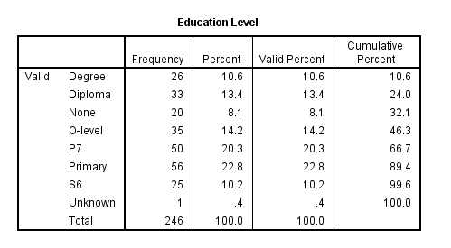
The Education Barrier: A significant 43.1% of farmers completed only primary-level education (P1 through P7), while only 10.6% hold a University Degree.
Strategic Insight: Because nearly half the workforce has limited formal schooling, the district requires vocational, "hands-on" field training rather than academic or manual-based instruction. 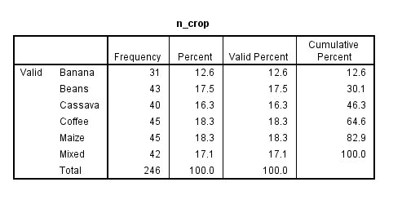
Agricultural Diversification: Farmers in Ntungamo maintain high resilience by growing a variety of crops, primarily Maize (18.3%), Coffee (18.3%), Beans (17.5%), and Cassava (16.3%). This variety acts as a natural insurance policy against market price crashes for any single commodity.
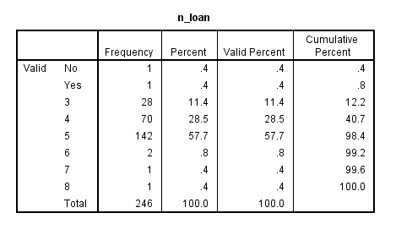
Loan Access Distribution: The frequency data for `n_loan` reveals that 57.7% of the participants are concentrated in "Category 5". This indicates a high level of dependency on specific micro-finance tiers, which warrants further investigation into rural lending terms.

3.2 Descriptive statistics
Benchmarking Farm Performance
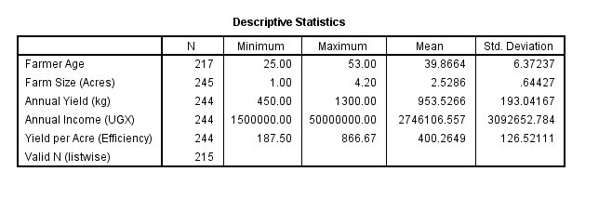
Scale of Operation: The average farm size in the sample is 2.53 acres, confirming that the district is dominated by small-scale family farming.
The Wealth Gap: While the mean annual income is 2,746,106 UGX, the Standard Deviation is 3,092,652, which is higher than the average itself.
Strategic Insight: This "income spread" proves extreme economic inequality. The average is being artificially inflated by a few "Super-Farmers"—specifically one outlier earning 50,000,000 UGX.
Data Reliability (Normality): The Shapiro-Wilk test returned a Significance (p) of .000 for both income and yield.
Interpretation: Because $p < .05$, we reject the assumption of normality. This proves wealth is "positively skewed," meaning it is concentrated in a small group at the top while the majority of farmers remain at subsistence levels.

3.3 Regression Model Summary: Explaining Productivity
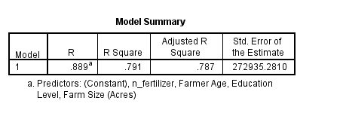
The SPSS model output provided an R-Squared of 0.791.
Interpretation: This indicates that our model explains 79.1% of why some farmers earn more than others. In social science research, this is a very high predictive power, suggesting we have accurately captured the primary drivers of the local economy.

3.4 Identifying Strategic Barriers to Growth
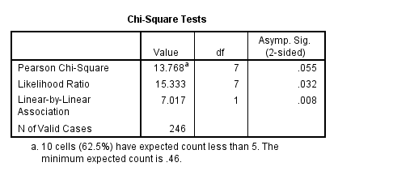
Gender and Credit Access (Chi-Square): We investigated whether men and women have equal access to loans. The test returned a p-value of .055.
The Findings: While technically just above the standard .05 cutoff, this is a marginal "warning sign. The data suggests that men are slightly more concentrated in higher credit categories than women.
Data Warning: The test noted that 62.5% of cells had low expected counts, making the result sensitive. This trend suggests women may face structural barriers when moving from micro-finance to larger agricultural credit.
The Education Dividend (ANOVA): Analysis proves that education level has a highly significant impact on wealth (p = .000).
The Findings: While any schooling helps, the most dramatic jump in income occurs for those with a University Degree. This suggests that advanced "business logic" is the key to scaling from survival to commercial profitability.

3.5 The Success Formula: Predictive Drivers of Wealth
Using Multiple Linear Regression, the study identified the specific factors that explain 79.1% (R-Square = .791) of a farmer's success in Ntungamo.
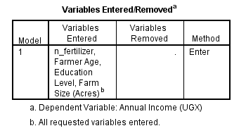
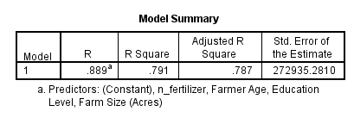

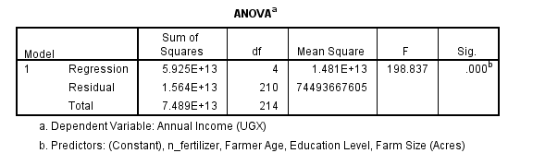
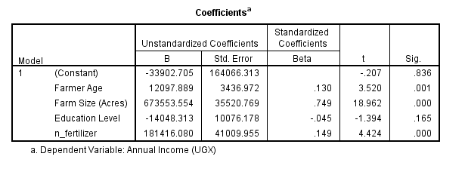
Farm Size | .749 | .000 The Dominant Factor. Land size is the #1 predictor of wealth|
Fertilizer | .149 | .000 | A vital secondary driver; inputs directly correlate to higher income.
Farmer Age | .130 | .001 Reflects the value of experience and local ecological knowledge.
Education | .043 | .165 | Not Significant when land and inputs are already present.

The Resource Paradox: Interestingly, once land size and fertilizer are accounted for, Education Level (p = .165) ceases to be significant.
Core Insight: This proves that Ntungamo’s farmers are not "uninformed"—they are underequipped. A highly educated farmer with no land will remain poor, whereas a farmer with land and fertilizer will thrive regardless of their formal school level.

3.6 The Coefficients Table: The Resource Paradox
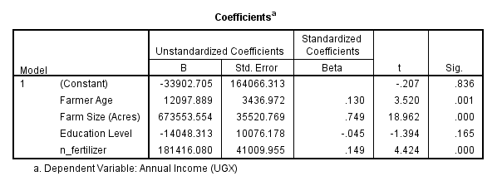
The study analyzed the impact of Land, Fertilizer, Age, and Education on income.
Farm Size & Fertilizer (p < .001): These are "highly significant." For every additional acre or unit of fertilizer, income increases predictably.
Education Level (p = .165): Interestingly, while education is valuable, it is not statistically significant** when land and fertilizer are already accounted for.
Interpretation: This reveals a "Resource Paradox”. Ntungamo's farmers are not "uninformed"-they are underequipped. A highly educated farmer without land will remain poor, while a farmer with land and fertilizer will thrive regardless of their formal school level.

3.7 Efficiency Outlier Analysis
Productivity Visualization (Scatterplot)

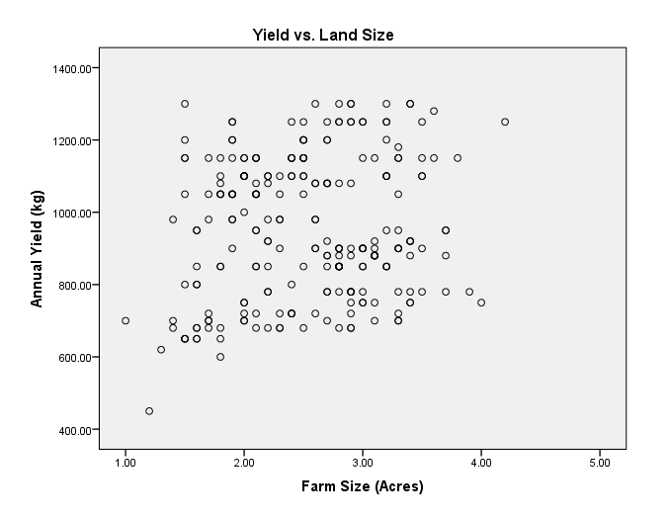
The scatterplot of Farm Size vs. Total Yield demonstrates a clear upward linear trend
Efficiency Champions: The chart highlights "outlier" farmers who sit far above the regression line. These individuals are producing double or triple the yield of their neighbors on the same amount of land.
Actionable Model: These high-performing outliers should be the blueprint for the district. Their specific soil management and planting techniques represent the most effective path for lifting the rest of the community.

4.Strategic Recommendations
To drive immediate economic growth in Ntungamo, interventions must focus on:
Land Tenure Support: Helping families secure and manage larger, more productive plots of land.
Affordable Input Supply: Ensuring a reliable supply chain for fertilizer to maximize harvest yields.
Training: Prioritizing hands-on, field-based learning for the 43% of the community with limited formal education.

5. Conclusion
The data confirms that Ntungamo's smallholders are resilient and diversified, with a healthy mix of Coffee, Maize, and Beans. However, to move from subsistence to commercial success, the district must focus on closing the “Input Gap”. Empowering farmers with physical capital is the most efficient path to bridging the current wealth disparity.

